[1]

CSE 222A Project Report

Brandon Gautama, Chi Hung Cheng, Jiacheng Luo   
Department of Computer Science and Engineering  
University of California, San Diego

*Abstract*—The common transport protocols used nowadays stand at two extremes. TCP transport packets reliably while UDP transport packets unreliably but has the benefit of better performance. Using either one of those to support live video streaming applications suffers from various drawbacks. Not surprisingly, many different transport protocols have been built on top of UDP to support video streaming applications such as SCTP, RSTP and QUIC. In this paper, we present a study on the pros and cons of these protocols for video streaming. Afterwards, we designed a new protocol optimized for live streaming applications. In addition, we evaluated our protocol and show that it has a better performance than TCP and UDP used alone.

*Index Terms*—Live Streaming Protocol, Transport Layer Protocol, Video Streaming Applications, Networks.

# Introduction

T

HE common transport protocols used nowadays stand at two extremes. TCP transport packets reliably while UDP transport packets unreliably but has the benefit of better performance. Using either one of those to support live video streaming applications suffers from various drawbacks. First, TCP has to make sure that data is reliably transferred, so it brings extra overhead and suffers from poor performance for live streaming purposes. Second, UDP suffers from too much packet dropped to reconstruct a video frame.

Not surprisingly, many different transport protocols have been built on top of UDP to support video streaming applications such as SCTP, RSTP and QUIC. In this paper, we present a study on the pros and cons of these protocols for video streaming. Afterwards, we designed a new protocol optimized for live streaming applications. In addition, we evaluated our protocol and show that it has a better performance than TCP and UDP used alone. In particular, our protocol will make use of multiple streams to deliver frames reliably and unreliably at the same time.

In this paper, we will first outline the common video streaming protocols nowadays, identify their pros and cons. Afterwards, we will outline the requirements for our live streaming protocol called DSP and present the design arguments for the features of our live streaming protocol. We will also present the design challenges that we met throughout the process. Finally, we evaluate our live streaming protocol based on several requirements. We show that out live streaming protocol exceeds the performance of the other current protocols.

# Background

## Motivation

The purpose of our project is to implement a transport protocol for fast live video streaming. Many applications nowadays require combination of TCP and UDP. For example, live chat and online collaboration tools. But for this paper, we are going to test it for live video streaming purpose.

DSP is built to run on wide area networks. In order to implement a better web service or application, traffics should be fast enough and at the same time, reliable for different parts of the features.

## Video Streaming

In video streaming, there are different frames with different reliability requirements. I frames are more important than B and P frames. The I frame has to be delivered reliably as the construction of video using B and P frames is dependent on the availability of the I frame associated. Because B and P frames contains the offset and not the original data. So, they are more lightweight.

# Current Protocols

## SCTP (Stream Control Transmission Protocol

1. Transmission Flow
   1. Use Four-way handshake to initiate a connection between hosts.
   2. Pack multiple data chunks in to one SCTP packet.
   3. Use Transmission Sequence Number (similar to TCP sequence number) mark each data chunk.
   4. Request retransmission if packet loss detected. Source either retransmit or decide not to retransmit and inform the receiver of its decision. Thus, it provides partially reliable transmission.
   5. Receiver sends three consecutive acks to trigger fast retransmission
2. Features
   1. Partially reliable transmission
   2. More flexible than TCP
   3. Fast retransmission
   4. Switch to a new path in transport layer to avoid network layer protocol convergence overhead.
3. Problems for real-time streaming
   1. Doesn’t satisfy 1.a.(ii, iii) and 1.b.

## RTP (Real-Time Transfer Protocol)

## RTP is the transport protocol for the delivery of real-time data, including streaming audio and video, video conference. RTP does not address the issue of resource reservation or quality of service control; instead, it relies on resource reservation protocols such as RSVP.

1. Transmission flow
   1. Use signaling protocols to initialize an RTP session between participants.
   2. Send BYE message to exit a session.
2. Features
   1. RTP doesn’t provide reliability of transfer. It depends on the layer under it. Some use TCP connections but most people use UDP.
   2. It provides multicast mechanism.
3. Possible problem
   1. Some unnecessary header fields for video streaming, like SSRC and CSRC etc.
   2. Doesn’t specify how to provide reliability.

## RTCP (Real-Time Transfer Control Protocol)

It is used in conjunction with RTP to send QoS and participants information.

## RSVP (Resource Reservation Protocol)

RSVP (generally) requires reserving resources for real time applications along data flows through QoS’s

Process flows:

1. Request QoS (quality of service) for each router along the data path to maintain router and host state to provide the service
2. Calls admission control to check resource availability and policy control to check user eligibility
3. If process above succeeds, parameters are packet classifiers and packet scheduler to obtained the desired QoS
4. reservation requests are receiver-oriented, and merge when they progress up the multicast tree. The reservation for a single receiver travels only until it reaches a reserved branch of the tree

Feature:

1. Scalable
2. Supports both multicasting and unicasting
3. RSVP maintains “soft state” in the routers. The only permanent state is in the end systems, which periodically send their RSVP control messages to

## RTSP (Real-time Streaming Protocol)

RTSP is application-level protocol with syntax and operations, it uses URLs like HTTP, but works for audio/video. RTSP does not deliver data. RTP and RTSP will likely be used together in many systems, but each can be used without the other

Process flow:

1. Video streaming is identified by an RTSP URL, where its properties are defined in a presentation description file, which includes encoding, language, RTSP URLs, destination address, port, and other parameters. The file can be obtained using HTTP, email or other means.
2. It chooses delivery channels (such as UDP, multicast UDP and TCP). RTSP messages are be carried out-of-band. (different from the data delivery protocol)
3. Upon receiving enough packets, the user software can play one packet, decompress another and receive a third
4. Services and operations are implemented using methods (OPTIONS, DESCRIBE, ANNOUNCE, SETUP, PLAY, PAUSE, TEARDOWN, GET_PARAMETER, SET_PARAMETER, REDIRECT, RECORD)
5. 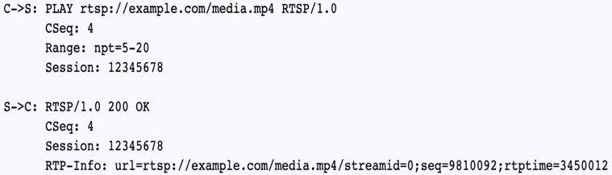
6. While HTTP is a stateless protocol, an RTSP server has to maintain "session states" in order to correlate RTSP requests with a stream.

Features:

1. Scalability
2. Supports both multicasting and unicasting
3. Bidirectionality enabling full stream control: Unlike HTTP, in RTSP both servers
4. and clients can issue requests.
5. It works with low-level protocol like RTP
6. Low overhead data delivery
7. Implemented on multiple operating system platforms, supports interoperability between clients and servers from different vendors/manufacturers
8. RTSP requests can be transmitted in persistent transport connections, or as a one connection per request/response transaction, or in connectionless mode.

## QUIC (Quick UDP Internet Connections)

a. Connection Establishment

1. The client must first perform a 1-roundtrip handshake to acquire the necessary information to complete the handshake.
2. The client sends an inchoate (empty) client hello (CHLO), the server sends a rejection (REJ) with the information the client needs to make forward progress, including the source address token and the server’s certificates.
3. The next time the client sends a CHLO, it can use the cached credentials to immediately send encrypted requests to the server.

b. Major Features

1. Congestion Control

Both original and retransmitted, carries a new sequence number. This allows a QUIC sender to distinguish retransmissions from originals and avoids TCP’s retransmission ambiguity. QUIC ACKs carry the delay between the receipt of a packet and its acknowledgment being sent. Together with the monotonically-increasing sequence numbers, this allows for precise roundtrip-time calculation.

1. Multiplexing  
   Because QUIC is designed from the ground up for multiplexed operation, lost packets carrying data for an individual stream only affect that specific stream. So unaffected streams can continue to be reassembled and make forward progress in the application.
2. Connection Migration  
   QUIC connections are identified by a 64 bit connection ID, randomly generated by the client. In contrast, TCP connections are identified by a 4-tuple of source address, source port, destination address and destination port. If a client changes IP addresses (for example, by moving out of Wi-Fi range and switching over to cellular) or ports (if a NAT box loses and rebinds the port association), any active TCP connections are no longer valid. When a QUIC client changes IP addresses, it can continue to use the old connection ID from the new IP address without interrupting any in-flight requests.

c. Built on top of UDP – similar to TCP+TLS+HTTP/2

d. Reduces latency – connection establishment time

e. Deployable, secure, reduced handshake and head-of-line blocking delays

f. Support multiple streams

g. Key advantages of QUIC over TCP + TLS + HTTP2 include:

1. Faster connection establishment latency
2. Improved congestion control
3. Multiplexing without head-of-line blocking
4. Forward error correction
5. Connection migration

## QUIC Fix

1. Addition of unreliable stream
2. Reliability depends on the frame importance
3. Reliable stream for I frame and control stream
4. Unreliable for b and p frame
5. Added error correction
6. Backward compatible
7. Transmit next chunks instead of retransmit for unreliable stream

## Comparison Table



# Requirements of DSP

What do we expect from a real-time streaming transmission protocol?

1. Real-time delivery (how do we define “real-time”)
   1. No need of reliable transmission. Partially reliable is acceptable.
   2. Don’t request outdated data (how do we define “outdated”)
   3. Don’t resend outdated data
2. Bit rate adjustment to
   1. Receiver’s capability
   2. Network congestion – not needed because data is sent according to the necessary bit rate and not as much as possible
   3. Network failure
3. In-order delivery
4. Make use of one source multiple destination pattern
5. Low overhead

# Features of DSP

To cater to the nature of video live streaming, our protocol will open 2 socket streams on top of UDP. One reliable stream (for I frames) and one unreliable stream (for b and p frames) for  applications. For reliable stream, we also provide real-time availability to applications. When the data is partially received, it is available for application to read. For example, when application needs the next I frame to decode following frames, it can read a partially received I frame from protocol buffer. Our protocol informs the application when the data is fully received.

Our protocol provides in-order delivery to applications and uses out-of-order acknowledgements to trigger fast retransmission in reliable stream. Our protocol utilizes forward error correction (FEC) to reduce number of retransmissions.

1. Unreliable stream
   1. Receiver puts received data into a buffer that is accessible to application. When received out-of-order packets, receiver use the previous packets as a placeholder in the position of the expected packet in the buffer. For example, receiver just received seq=100, and now receives seq = 102, what will be put in to buffer is seq=100, seq=100, seq=102. When packet seq=101 actually arrived, receiver could replace the placeholder in buffer with the actual packet if the content is not consumed by the application yet.
2. Real-time availability and reliable stream
   1. Reliable is ensured using a similar way to TCP and SCTP ACK. Each packet received by the receiver will be replied with an ACK in a cumulative way. If there is gap in the packet received, both eACK and timeout is used to ensure a faster delivery.
   2. eACK is used to ACK a packet when there is a gap in the buffer. In this way, the sender does not have to wait for timeout to retransmit. For example, the receiver received seq=100 and seq=102 but not seq=101. The receiver will send an ACK for seq=100 and an eACK for seq=102. When the sender receive an eACK for seq=102, the sender knows that seq=100 has been ACKed but not seq=101. So it will retransmit seq=101 without waiting for timeout to occur. But we still need a timeout mechanism when there is receiver does not send any ACK/eACK.
3. In-order delivery and out-of-order ack
   1. Reorder received packets in the protocol buffer
   2. When received an out-of-order packet, receiver sends an eACK to sender to trigger fast retransmission. Note that the expected packet may be lost or may be still in the network.
4. Forward error correction
   1. Use FEC to reduce number of retransmissions
   2. The frequency of FEC packet is negotiate at the connection establishment.
5. Flow control
   1. The flow control of unreliable stream is not based on window size but rather based on credit. So, the receiver will have a header stating the number of packets the sender should receive.
   2. The flow control of reliable stream is based on window. However unlike TCP, to eliminate head-of-line blocking, we use a discrete window to store unacked packets. Upon receiving an ack, we pop the acked packet out of the window and push a new packet in.
6. Congestion Control
   1. Since our protocol targets live stream, whose sending rate is fixed to the content generation rate, congestion control is not needed. When there is a congestion and packet loss, we can use a control protocol to adjust the video quality and reduce the bit rate.



Table 1 Data loss avoidance 1, send duplicate I-frame; Probability that a packet still drops v.s. # of time it’s sent as duplicates



Table 2 Data loss avoidance 2, send via forward error correction; Probability that a packet drops v.s. Number of total packets sent using error correction

A primary section heading is enumerated by a Roman numeral followed by a period and is centered above the text. A primary heading should be in capital letters.

A secondary section heading is enumerated by a capital letter followed by a period and is flush left above the section. The first letter of each important word is capitalized and the heading is italicized.

A tertiary section heading is enumerated by an arabic numeral followed by a parenthesis. It is indented and is followed by a colon. The first letter of each important word is capitalized and the heading is italicized.

A quaternary section heading is rarely necessary, but is perfectly acceptable if required. It is enumerated by a lowercase letter followed by a parenthesis. It is indented and is followed by a colon. Only the first letter of the heading is capitalized and the heading is italicized.

TABLE I

Samples of Times Roman Type Sizes and Styles

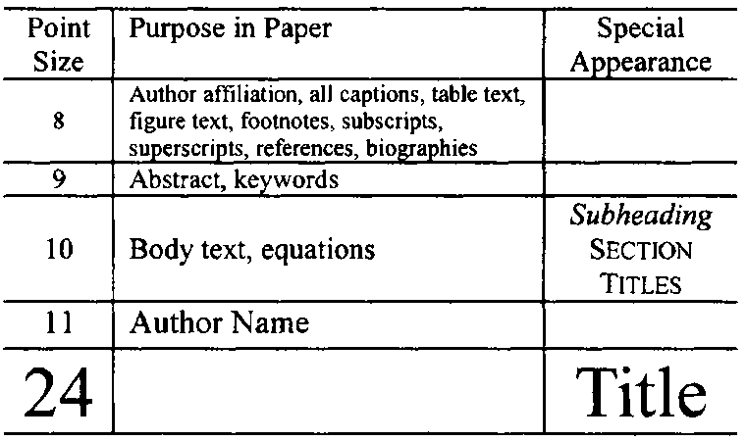

## Figures and Tables

Figure axis labels are often a source of confusion. Try to use words rather than symbols. As an example, write the quantity “Magnetization,” or “Magnetization, *M*,” not just “*M*.” Put units in parentheses. Do not label axes only with units. As in Fig. 1, write “Magnetization (kA/m)” or “Magnetization (kA·m-1),” not just “kA/m.” Do not label axes with a ratio of quantities and units. For example, write “Temperature (K),” not “Temperature/K.” Figure labels should be legible, approximately 8- to 10-point type.

The IEEE Graphics Analyzer Tool enables authors to pre-screen their graphics for compliance with IEEE Transactions and Journals standards before submission. The online tool is located at http://graphicsqc.ieee.org/.

To insert images in Microsoft Word, position the cursor at the insertion point and either use Insert | Picture | Insert Picture from File or copy the image to the Windows clipboard and then use Home | Paste | Paste Special | Picture. All figures and tables must be in place in the text near, but not before, where they are first mentioned.

Large figures and tables may span both columns, but may not extend into the page margins. Figure captions should be below the figures; table captions should be above the tables. Do not put captions in “text boxes” linked to the figures. Do not put borders around your figures. Use the abbreviation “Fig. 1,” even at the beginning of a sentence.

## Numbering

Number reference citations consecutively in square brackets [1]. The sentence punctuation follows the brackets [2]. Multiple references [2], [3] are each numbered with separate brackets [1]-[3]. Refer simply to the reference number, as in [3]. Do not use “Ref. [3]” or “reference [3]” except at the beginning of a sentence: “Reference [3] shows….”

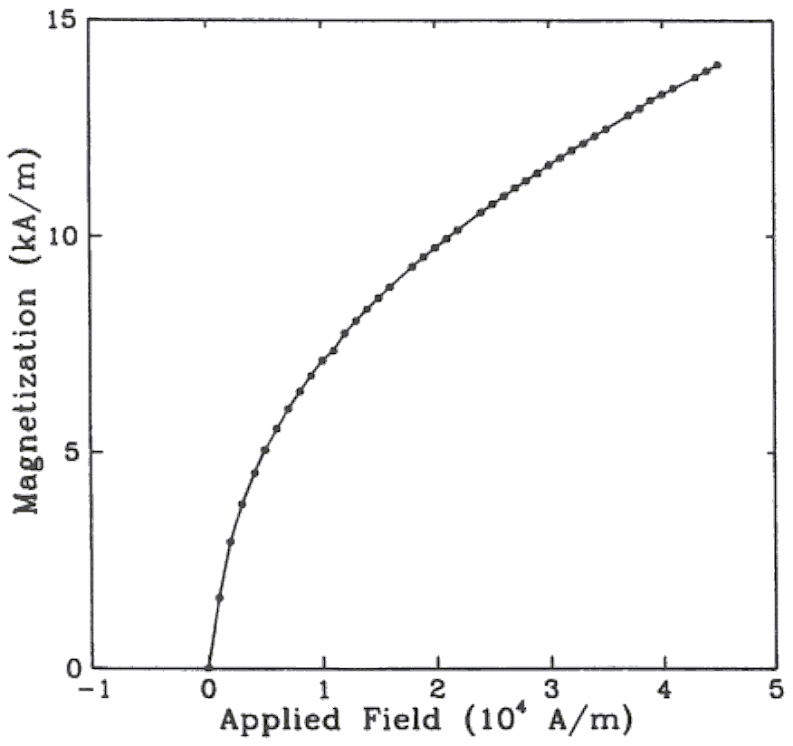

Fig. 1. Magnetization as a function of applied field. (Note that “Fig.” is abbreviated and there is a period after the figure number followed by two spaces.)

Number footnotes separately with superscripts (References | Insert Footnote). Place the actual footnote at the bottom of the column in which it is cited. Do not put footnotes in the reference list. Use letters for table footnotes.

Check that all figures and tables are numbered correctly. Use arabic numerals for figures and Roman numerals for tables.

Appendix figures and tables should be numbered consecutively with the figures and tables appearing in the rest of the paper. They should not have their own numbering system.

## Units

Metric units are preferred for use in IEEE publications in light of their global readership and the inherent convenience of these units in many fields. In particular, the use of the International System of Units (Systeme Internationale d'Unites or SI Units) is advocated. This system includes a subsystem of units based on the meter, kilogram, second, and ampere (MKSA). British units may be used as secondary units (in parentheses). An exception is when British units are used as identifiers in trade, such as 3.5-inch disk drive.

## Abbreviations and Acronyms

Define less common abbreviations and acronyms the first time they are used in the text, even after they have been defined in the abstract. Abbreviations such as IEEE, SI, MKS, CGS, ac, dc, and rms do not have to be defined. Do not use abbreviations in the title unless they are unavoidable.

See Appendix A of the Author’s Kit for additional information and standard abbreviations.

## Math and Equations

Use either the Microsoft Equation Editor or the *MathType* commercial add-on for MS Word for all math objects in your paper (Insert | Equation *or* MathType Equation).

To make your equations more compact, you may use the solidus ( / ), the exp function, or appropriate exponents. Italicize Roman symbols for quantities and variables, but not Greek symbols. Use a long dash rather than a hyphen for a minus sign. Use parentheses to avoid ambiguities in denominators.

Number equations consecutively with equation numbers in parentheses flush with the right margin, as in (1). Be sure that the symbols in your equation have been defined before the equation appears or immediately following.

where *IF* is the fault current.

Use “(1),” not “Eq. (1)” or “equation (1),” except at the beginning of a sentence: “Equation (1) is .…”

# Appendix

Appendixes, if needed, appear before the acknowledgment.

# Acknowledgment

The following is an example of an acknowledgment. (Please note that financial support should be acknowledged in the unnumbered footnote on the title page.)

The authors gratefully acknowledge the contributions of I. X. Austan, A. H. Burgmeyer, C. J. Essel, and S. H. Gold for their work on the original version of this document.

# References

*Basic format for books:*

1. J. K. Author, “Title of chapter in the book,” in *Title of His Published Book,* xth ed. City of Publisher, Country if not USA: Abbrev. of Publisher, year, ch. x, sec. x, pp. xxx–xxx.

*Examples:*

1. G. O. Young, “Synthetic structure of industrial plastics,” in *Plastics,* 2nd ed., vol. 3, J. Peters, Ed. New York: McGraw-Hill, 1964, pp. 15–64.
2. W.-K. Chen, *Linear Networks and Systems.* Belmont, CA: Wadsworth, 1993, pp. 123–135.

*Basic format for periodicals:*

1. J. K. Author, “Name of paper,” *Abbrev. Title of Periodical,* vol. x, no. x, pp. xxx–xxx, Abbrev. Month, year.

Examples:

1. J. U. Duncombe, “Infrared navigation—Part I: An assessment of feasibility,” *IEEE Trans. Electron Devices,* vol. ED-11, no. 1, pp. 34–39, Jan. 1959.
2. E. P. Wigner, “Theory of traveling-wave optical laser,” *Phys. Rev.,* vol. 134, pp. A635–A646, Dec. 1965.
3. E. H. Miller, “A note on reflector arrays,” *IEEE Trans. Antennas Propagat.,* to be published.

*Basic format for reports:*

1. J. K. Author, “Title of report,” Abbrev. Name of Co., City of Co., Abbrev. State, Rep. xxx, year.

*Examples:*

1. E. E. Reber, R. L. Michell, and C. J. Carter, “Oxygen absorption in the earth’s atmosphere,” Aerospace Corp., Los Angeles, CA, Tech. Rep. TR-0200 (4230-46)-3, Nov. 1988.
2. J. H. Davis and J. R. Cogdell, “Calibration program for the 16-foot antenna,” Elect. Eng. Res. Lab., Univ. Texas, Austin, Tech. Memo. NGL-006-69-3, Nov. 15, 1987.

*Basic format for handbooks:*

1. *Name of Manual/Handbook,* x ed., Abbrev. Name of Co., City of Co., Abbrev. State, year, pp. xxx–xxx.

*Examples:*

1. *Transmission Systems for Communications,* 3rd ed., Western Electric Co., Winston-Salem, NC, 1985, pp. 44–60.
2. *Motorola Semiconductor Data Manual,* Motorola Semiconductor Products Inc., Phoenix, AZ, 1989.

*Basic format for books (when available online):*

1. Author. (year, month day). *Title.* (edition) [Type of medium]. *volume (issue).* Available: site/path/file

*Example:*

1. J. Jones. (1991, May 10). *Networks.* (2nd ed.) [Online]. Available: http://www.atm.com

*Basic format for journals (when available online):*

1. Author. (year, month). Title. *Journal.* [Type of medium]. *volume (issue),* pages. Available: site/path/file

*Example:*

1. R. J. Vidmar. (1992, Aug.). On the use of atmospheric plasmas as electromagnetic reflectors. *IEEE Trans. Plasma Sci.* [Online]. *21(3),* pp. 876–880. Available: http://www.halcyon.com/pub/journals/21ps03-vidmar

*Basic format for papers presented at conferences (when available online):*

1. Author. (year, month). Title. Presented at Conference title. [Type of medium]. Available: site/path/file

*Example:*

1. PROCESS Corp., MA. Intranets: Internet technologies deployed behind the firewall for corporate productivity. Presented at INET96 Annual Meeting. [Online]. Available: http://home.process.com/Intranets/wp2.htp

*Basic format for reports and handbooks (when available online):*

1. Author. (year, month). Title. Company. City, State or Country. [Type of medium]. Available: site/path/file

*Example:*

1. S. L. Talleen. (1996, Apr.). The Intranet Architecture: Managing information in the new paradigm. Amdahl Corp., CA. [Online]. Available: http://www.amdahl.com/doc/products/bsg/intra/infra/html

*Basic format for computer programs and electronic documents (when available online):* ISO recommends that capitalization follow the accepted practice for the language or script in which the information is given.

*Example:*

1. A. Harriman. (1993, June). Compendium of genealogical software. *Humanist.* [Online]. Available e-mail: HUMANIST@NYVM.ORG Message: get GENEALOGY REPORT

*Basic format for patents (when available online):*

1. Name of the invention, by inventor’s name. (year, month day). *Patent Number* [Type of medium]. Available: site/path/file

*Example:*

1. Musical toothbrush with adjustable neck and mirror, by L. M. R. Brooks. (1992, May 19). *Patent D 326 189* [Online]. Available: NEXIS Library: LEXPAT File: DESIGN

*Basic format for conference proceedings (published):*

1. J. K. Author, “Title of paper,” in *Abbreviated Name of Conf.,* City of Conf., Abbrev. State (if given), year, pp. xxx–xxx.

*Example:*

1. D. B. Payne and J. R. Stern, “Wavelength-switched passively coupled single-mode optical network,” in *Proc. IOOC-ECOC,* 1985, pp. 585–590.

*Example for papers presented at conferences (unpublished):*

1. D. Ebehard and E. Voges, “Digital single sideband detection for interferometric sensors,” presented at the 2nd Int. Conf. Optical Fiber Sensors, Stuttgart, Germany, Jan. 2–5, 1984.

*Basic format for patents:*

1. J. K. Author, “Title of patent,” U.S. Patent x xxx xxx, Abbrev. Month, day, year.

*Example:*

1. G. Brandli and M. Dick, “Alternating current fed power supply,” U.S. Patent 4 084 217, Nov. 4, 1978.

*Basic format for theses (M.S.) and dissertations (Ph.D.):*

1. J. K. Author, “Title of thesis,” M.S. thesis, Abbrev. Dept., Abbrev. Univ., City of Univ., Abbrev. State, year.
2. J. K. Author, “Title of dissertation,” Ph.D. dissertation, Abbrev. Dept., Abbrev. Univ., City of Univ., Abbrev. State, year.

*Examples:*

1. J. O. Williams, “Narrow-band analyzer,” Ph.D. dissertation, Dept. Elect. Eng., Harvard Univ., Cambridge, MA, 1993.
2. N. Kawasaki, “Parametric study of thermal and chemical nonequilibrium nozzle flow,” M.S. thesis, Dept. Electron. Eng., Osaka Univ., Osaka, Japan, 1993.

*Basic format for the most common types of unpublished references:*

1. J. K. Author, private communication, Abbrev. Month, year.
2. J. K. Author, “Title of paper,” unpublished.
3. J. K. Author, “Title of paper,” to be published.

*Examples:*

1. A. Harrison, private communication, May 1995.
2. B. Smith, “An approach to graphs of linear forms,” unpublished.
3. A. Brahms, “Representation error for real numbers in binary computer arithmetic,” IEEE Computer Group Repository, Paper R-67-85.

*Basic format for standards:*

1. *Title of Standard,* Standard number, date.

*Examples:*

1. *IEEE Criteria for Class IE Electric Systems,* IEEE Standard 308, 1969.
2. *Letter Symbols for Quantities,* ANSI Standard Y10.5-1968.

1.